Ideation Phase
Define the Problem Statements

Date | 10 July 2026
Team ID | Individual Project
Project Name | Library Book Request Management System
Maximum Marks | 2 Marks

Customer Problem Statement Template:
The Customer Problem Statement helps identify the challenges faced by users and understand their requirements from a practical perspective. It focuses on the customer's goals, the obstacles they face, the reasons behind those challenges, and the expected solution. This analysis helps in designing a system that effectively addresses real-world problems.
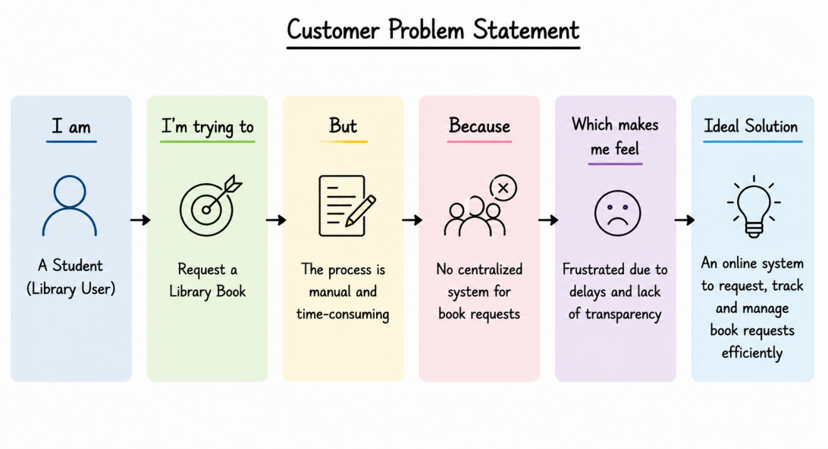

Problem Statement (PS) | I am (Customer) | I’m trying to | But | Because | Which makes me feel
PS-1 | A Student | Request a library book online | The current process is manual and difficult to track | There is no centralized system for submitting and monitoring book requests | Frustrated and delayed
PS-2 | A Librarian | Manage and respond to book requests efficiently | Book requests are received manually and records are difficult to maintain | The approval process is not automated | Overloaded and inefficient

